NEW CONCEPTS
DOCK – Instead na isakto ang ilalagay na panel sa kunyari Top Part ng Window. Ginagawa ng Dock na magsasakto sya na parang nakakabit sa Top Part nung Window and Nakafill.
ANCHOR – Since nagiiba ang size ng Windows, Ang anchor naghehelp para magstay ang isang object sa side na gusto mo without altering its size. Kunyari yung Minimize Buttons, naka anchor sa Top-Right.
Create a Project > Windows Forms App (.NET Framework)
NEEDED ADDITION SA FILE
CRUD FOLDER: Right Click Surname_EMS > Add > New Folder > Rename as “CRUD”
connection class: Right Click CRUD folder > Add > Class > Rename as “connection”
CRUD class: Right Click CRUD folder > Add > Class > Rename as “CRUD”
Common class: Right Click Surname_EMS > Add > Class > Rename as “Common”
LAYOUTING NG FORMS
FORM 1
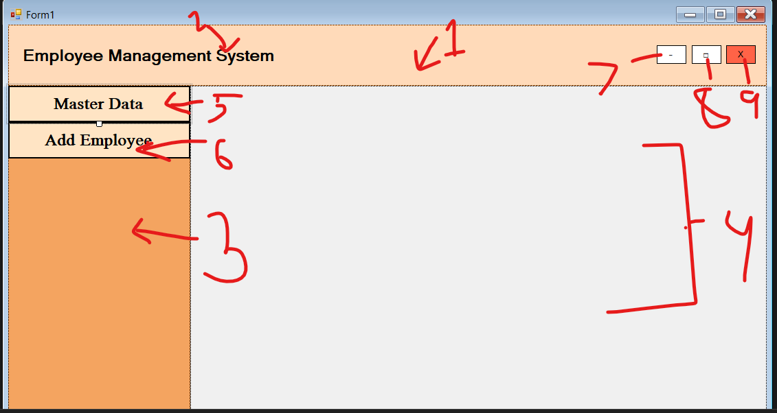
- Panel – Name: pnlTitleBar, Dock: Top
- Label – Name: lblSystemName, Nasa loob dapat nung Top Panel. Font: Microsoft Sans Serif, 14.2, Bold (Dito lang mahalaga yung font).
- Panel – Name: pnlSideMenu, Dock: Left
- Panel – Name: pnlStage, Dock: Fill
- Button – Name: btnMasterData, Flat Style: Flat, Pede baguhin yung design ng Border sa Flat Appearance, Bago I-dock make sure nasa loob ng Side Panel yung button then Dock: Top.
- Button – Name: btnAddEmployee, Flat Style: Flat, Pede baguhin yung design ng Border sa Flat Appearance, Bago I-dock make sure nasa loob ng Side Panel yung button then Dock: Top
- Button – Name: btnMinimize, Anchor: Top-Right
- Button – Name: btnMaximize, Anchor: Top-Right
- Button – Name: btnClose, Anchor: Top-Right

Master Data Form – Right Click Surname_EMS sa Solution Explorer > Add > Form (Windows Form) > File Name: frmMasterData
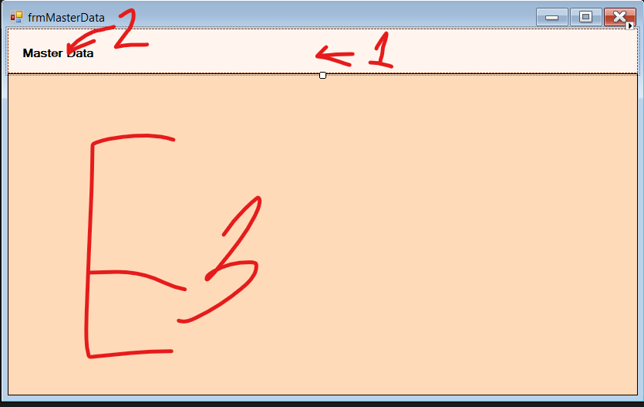
NOTE: Yung size ng Forms ay dapat kasing size nung pnlStage
- Panel – Name: pnlSubtitle, Dock Top
- Label – Name: lblMasterData
- Data Grid View – Name: dvgMasterdata, Dock: Fill

Add Employee Form – Right Click Surname_EMS sa Solution Explorer > Add > Form (Windows Form) > File Name: frmAddEmployee
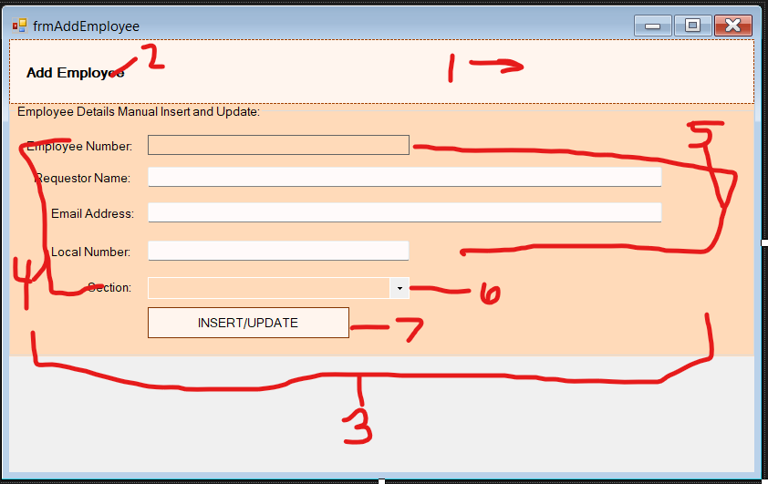
NOTE: Yung size ng Forms ay dapat kasing size nung pnlStage
- Panel – Name: pnlSubtitle, Dock: Top
- Label – Name: lblAddEmployee
- Group Box – Name: gbEmployeeInput, Dock: Top
- Label lahat – Name: lbl tapos yung text (e.g. lblEmployeeNumber)
- Text Box lahat – Name: tb tapos yung text sa label (e.g. tbEmployeeNumber)
- Combo Box – Name: cmbSection, DropDownStyle: DropDownList, Items: BPS, IT, HR, GA, Printer, Tape
- Button – Name: btnInsertUpdate

